Utilization Management and

Service Authorization Handbook

A collection of utilization management policies, procedures, and criteria for covered services to ensure consistent application of review criteria for authorization decisions. Participating Providers and Subcontractors must adhere to the policies and procedures set forth in this Service Authorization Handbook.

This Utilization Management (UM) and Service Authorization Handbook sets forth UHA’s utilization management policies, procedures, and criteria for covered services that comply with state and federal requirements (42 CFR §438.210 and OAR 410-141-3835) to ensure consistent application of review criteria for authorization decisions.

Umpqua Health Alliance (UHA) provides medically appropriate, cost-effective health services within the scope of the member's benefit package of health services in accordance with the Prioritized List of Health Services and the terms of the Coordinated Care Organization (CCO) Contract and Oregon Administrative Rules (OAR) 410-141-3820 and 410-141-3835.

DEFINITIONS
Covered Services – A medically necessary and appropriate health services and items described in ORS Chapter 414 and applicable administrative rules and the Prioritized List of Health Services above the funding line set by the legislature. Covered services include services that are:
- Ancillary services (OAR 410-120-0000(22));
- Diagnostic services necessary to determine the existence, nature, or extent of the client or member’s disease, disorder, disability or condition;
- Necessary for compliance with the requirements for parity in mental health and substance use disorder benefits in 42 CFR part 438, subpart k;
- Necessary for compliance with the requirements for Early and Periodic Screening, Diagnosis and Treatment as specified in the Oregon Health Plan 1115 Demonstration Project (waiver).

Medically Appropriate - A health services, items, or medical supplies that are:
- Recommended by a licensed health provider practicing within the scope of their license;
- Safe, effective, and appropriate for the patient based on standards of good health practice and generally recognized by the relevant scientific or professional community based on the best available evidence;
- Not solely for the convenience or preference of an OHP client, member, or a provider of the service item or medical supply;
- The most cost effective of the alternative levels or types of health services, items, or medical supplies that are covered services that can be safely and effectively provided to a Division client or member in the Division or MCE’s judgment;
- All covered services must be medically appropriate for the member or client, but not all medically appropriate services are covered services.

Medically Necessary - A health services and items that are required by a client or member to address one or more of the following:
- The prevention, diagnosis, or treatment of a client or member's disease, condition, or disorder that results in health impairments or a disability;
- The ability for a client or member to achieve age-appropriate growth and development;
- The ability for a client or member to attain, maintain, or regain independence in self-care, ability to perform activities of daily living or improve health status; or
- The opportunity for a client or member receiving Long Term Services & Supports (LTSS) as defined in these rules to have access to the benefits of non-institutionalized community living, to achieve person centered care goals, and to live and work in the setting of their choice;
- A medically necessary service must also be medically appropriate. All covered services must be medically necessary, but not all medically necessary services are covered services.

UTLIZATION MANAGEMENT PROGRAM OVERIVEW
Utilization Management (UM) is integrated within the Medical Management (Care Coordination) teams. The Directors of Utilization Management, Pharmacy and Care Coordination management oversee the program operations under the supervision of the Medical Director. Umpqua Health Alliance (UHA) provides utilization review in accordance with the policies, procedures, and criteria for covered services that comply with state and federal requirements (42 CFR §438.210 and OAR 410-141-3835) to ensure consistent application of review criteria for authorization decisions. Such reviews ensure medically appropriate, cost-effective health services within the scope of the member's benefit package of health services in accordance with the Prioritized List of Health Services and the terms of the Coordinated Care Organization (CCO) Contract and Oregon Administrative Rules (OAR) 410-141-3820 and 410-141-3835.

UHA has processes in place to provide covered services outlined in the contract that are no less than the amount, duration, and scope of the same services to beneficiaries under Fee-For-Service (FFS) Medicaid, and for members under the age of 21. UHA ensures that the services are sufficient in amount, duration, or scope to reasonably achieve the purpose for which the services are furnished. UHA does not arbitrarily deny or reduce the amount, duration, or scope of a required service solely because of diagnosis, type of illness, or condition of the beneficiary.

A request for services is required in order to determine, prior to delivery of care, if the requested service is part of the benefit plan and it meets the OHP coverage criteria. Prior Authorization (PA) requests will be addressed in a timely manner. Routine requests should be received by Umpqua Health Alliance (UHA) at least two (2) weeks before a planned service is scheduled. This allows time for UHA to process the PA and review pertinent medical information critical to the decision-making process. A copy of the Member’s chart notes, lab and/or x-ray tests, and any other pertinent facts should accompany the original request.

UHA is not structured so as to provide incentives for the individuals or entities that conduct utilization management activities to deny, limit, or discontinue medically necessary services to any member.

UHA shall maintain and ensure that its clinical providers maintain documentation that meets the standards specified in OAR 410-172-0620 (documentation standards), OAR 309-019-0135 (assessment) and OAR 309-019- 0140 (service plan and notes). These record-keeping requirements shall apply regardless of clinic provider’s licensure or certification status. Compliance with these clinical documentation standards is an express condition of payment under the Provider Network Agreement and the Oregon Health Plan (OHP) Plan Addendum.

An authorization does not guarantee benefits. The actual claim may be rejected for reasons such as the care provided differs from the care that was pre-authorized. Payment for care that has been pre-authorized will not be denied.
on the basis of medical necessity unless critical information was not given at the time of authorization (i.e., Member was given an experimental or investigational treatment that was not clearly stated in the authorization process.) If the Member has lost eligibility, the claim will not be paid regardless of an approved authorization.

UHA constitutes medically necessary covered services and administers the services in a manner that:
- Is no more restrictive than that used in the State Medicaid program, including quantitative and non-quantitative limits (as indicated in other State policies, procedures, and administrative rules).
- Considers and addresses the following:
  - The prevention, diagnosis, and treatment of a member’s disease, condition, and/or disorder that results in health impairments and/or disability.
  - The ability for a member to achieve age-appropriate growth and development.
  - The ability for a member to attain, maintain, or regain functional capacity.
  - The opportunity for a member receiving long-term services and supports to have access to the benefits of community living, to achieve person centered goals, and live and work in the setting of their choice.

PRIOR AUTHORIZATION REQUIREMENTS
Prior authorization requirements (PA) are listed within the PA Grid as posted on UHA’s prior authorization website. Emergency services do not require a PA.

All PA decisions for medical, pharmacy, dental, and behavioral health services are conducted by qualified healthcare professionals that have the necessary training and expertise to make authorization decisions. For more information refer to UHA policy CE05 – Utilization Review.

UHA may not authorize services under the following circumstances:
- The request received by UHA was not complete.
- The provider did not hold the appropriate license, certificate, or credential at the time services were requested.
- The recipient was not eligible for Medicaid at the time services were requested.
- The provider cannot produce appropriate documentation to support medical appropriateness, or the appropriate documentation was not submitted to UHA.
- The services requested are not in compliance with OAR 410-120-1260 through 410-120-1860.

UTLIZATION MANAGEMENT REVIEW CRITERIA
Prior authorization requests that require review are assessed for medical appropriateness and necessity by using the following resources:
- Prioritized List of Health Services (PLHS): The Oregon Health Evidence Review Commission (HERC) ranks health care condition and treatment pairs in order of clinical effectiveness and cost-effectiveness. The Prioritized List emphasizes prevention and patient education. In general, treatments that help prevent illness are ranked higher than services that treat an illness after it occurs. OHP covers treatments that are ranked on a covered Prioritized List line for the client's reported medical condition. OHP covers Prioritized List lines 1 through 471. Current Prioritized List can be found at https://www.oregon.gov/oha/HPA/DSI-HERC/Pages/Prioritized-List.aspx
- Guideline Notes: Using the Prioritized List for the line of coverage, based upon ICD-10, CPT, and HCPCS codes, UHA will then find the associated Guideline Note for treatment. These guidelines can be found at https://www.oregon.gov/oha/HSD/OHP/pages/policies.aspx.
- InterQual®: InterQual® is an evidence-based clinical decision support tool used to make clinically appropriate medical utilization decisions. UHA applies this tool to PA requests, including chiropractic services. The determination process includes the evaluation of the duration of treatment. Documentation of the InterQual® criteria is included in each PA used to make a determination in CIM, which can be accessed by CIM users.
- Oregon Administrative Rules (OAR): https://secure.sos.state.or.us/oard/ruleSearch.action
- Up-to-Date ® Wolters Kluwer: UpToDate is an evidence-based clinical decision support resource at the point of care.
- Clinical Practice Guidelines: Umpqua Health Alliance’s Clinical Practice Guidelines are adopted by UHA’s Clinical Advisory Panel. They can be found on the UHA website at https://www.umpquahealth.com/clinical-practice-guidelines/.
- American Society of Addiction Medicine (ASAM): The ASAM Criteria is the most widely used and comprehensive set of guidelines for placement, continued stay, transfer, or discharge of patients with addiction and co-occurring conditions.
- Functional Rating Index© Institute of Evidence-Based Chiropractic
- AllMed: Contracted Independent Review Organization UHA uses for evaluation of high cost DME or for any Expert Specialty review.
- CMS In-patient Hospitalization list of CPT codes paid only as Inpatient procedures.
- Medicare Local Coverage Determination (LCD) and National Coverage Determination (NCD)

UTLIZATION MANAGEMENT REVIEW TYPES
- Pre-service review: This are services that require a prior authorization review before the service is rendered. These include all elective procedures, hospitalization, outpatient services, out-of-network referrals and durable medical equipment as indicated on UHA’s PA Grid.
- Concurrent review: These requests are an extension of ongoing treatment or care. These are to be requested after the initial approval of a pre-service review and are required for all inpatient and/or residential care.
- Post-service review: These requests after the date of service. Any requests for authorization after 30 days from the date of service (90 days for Behavioral Health services) requires documentation from the provider that indicates why authorization could not be obtained within 30 days of the date of service. Post-service or retrospective reviews are discouraged and will need to be sent for provider appeals for coverage past these timelines.
- Amendments: These requests are to make a change after the final approval of an authorization. This includes changes/edits/additions of diagnosis codes, CPT/HCPC codes, date changes, provider changes, quantity changes. A request for additional visits will be considered a new request.

PRIOR AUTHORIZATION TIMELINES
In accordance with OAR 410-141-3835(10)(f)(C), received prior authorization requests will be date stamped upon receipt. Any prior authorization received after hours or on the weekend that requires prior authorization will be reviewed in accordance with the authorization timelines listed below. Emergent conditions do not require prior authorization. All requests will be reviewed and provide notice as expeditiously as the member's health or behavioral health condition requires. Any service authorization decision not reached within the timeframes specified under OAR 410-141-3835 as noted below, shall constitute a denial (adverse benefit determination). A notice of adverse benefit determination shall be issued on the date the timeframe expires.
Authorization Type | Timeline | Urgency
Standard requests | 14 days | Standard
Expedite requests.  - Select only when the standard review timeframe could seriously jeopardize the member's life, health, or ability to attain, maintain, or regain maximum function" in accordance with 42 CFR 438.210(d)(2)(i)) | 72 hours | Expedite
Behavioral Health - SUD - Detox  Behavioral Health - SUD - Residential | 2 BD | Standard
Skilled Nursing Facility (SNF) | 2 BD | Standard
Behavioral Health - IP Adult  Behavioral Health - IP Child  Behavioral Health - PRTS  Behavioral Health - Res Adult | 72 hours | Standard
Timeframe extensions  - These can occur if the member or the provider requests an extension, or UHA justifies a need for additional information. It will include how the extension is in the member’s interest.  - If the UHA extends the time frame for standard or expedited authorization decisions, we will let the member know the reason for the extension in writing before the end of the authorization time frame expires. This letter will let them know that they can file a grievance they disagree with that decision.  - An extension will be processed expeditiously as the member's health condition requires and no later than the date the extension expires. | 14 days | Standard/Expedite

COMMUNICATIONS
All PA communications should be made through PA request to Priorauthorizations@umpquahealth.com. Please utilize the CIM email function for communications with UHA staff as they pertain to prior authorizations. These communications provide important clarifications that affect the review of the PA, notices of determination, and requests for documentation. Communications for past due information will be processed through the approved PA request by our support specialist team. Please reply with any updated information to PriorAuthorizations@umpquahealth.com and attaching the documentation to the PA in reference.

SUBMITTING A PRIOR AUTHORIZATION REQUEST
Out-of-network providers can send their authorization request via fax to 541-677-5881 using our Prior Authorization form found on our website at www.umpquahealth.com.
In-network providers are required to have electronic access, to submit, check the status, and manage your prior authorization requests online. By signing up for access to our Community Integration Manager (CIM), you can eliminate paperwork and fax associated with the authorization process. You will also have direct email access to our Customer Care, Prior Authorization, and Claims teams that can assist you with questions of member eligibility and monitoring PA and claims status.’ UHA requires all participating providers to submit their PA requests electronically. Each office staff member from the provider’s office will need a separate log in. To sign up for this feature, please visit https://help.phtech.com. Select the “Sign in” link in the top-right header.
Submission Instructions
- From the member search option, enter the member’s ID and select search.  - Verify member eligibility and coverage type and if the member has other coverage (COB).  - CCOA, CCOB  (Needed for medical benefits)  - CCOG, CCOE  (Needed for BH benefits)  - Select “Submit Pre-Auth” in the top right corner.  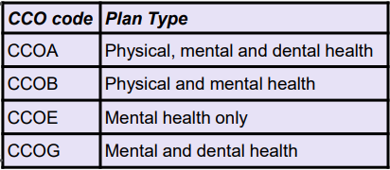 | 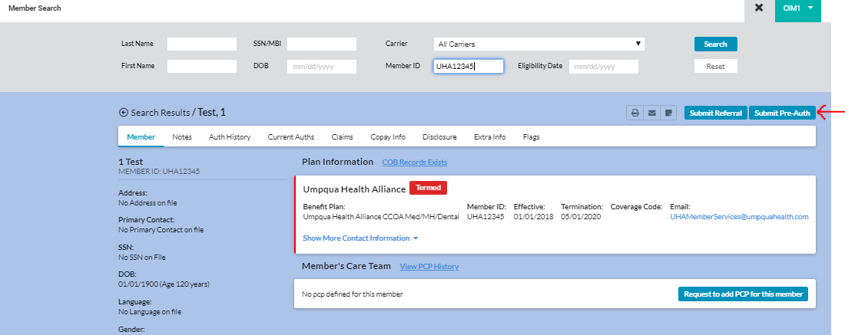
- From the new Assign a Type of Care page, select “Pre-Authorization.”  - Select “START” in the bottom of the Pre-Authorization box.  - Start Date & End Date: Update these dates according to the request. The calendar icon will calculate the date for you based on the options listed. If a request is received without a specific start date, default to the day the request was received. If an end date is not specified, the default time for a is one month.  - Please see the Standard PA Duration section for allowed timeframes.  - Then select “START” in the bottom of the box appropriate care type. | 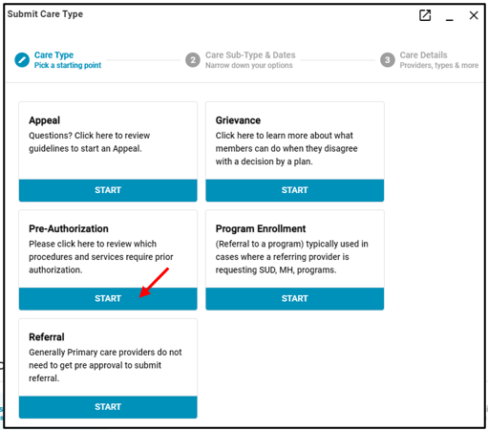  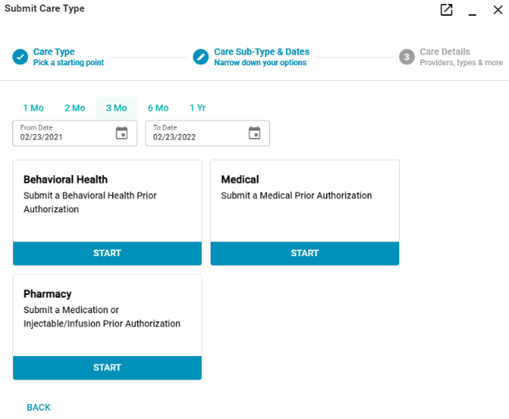
- Next, click on the first box that states, “Select an Auth Type.” Select as applicable.  - All requests will be a standard urgency status unless the standard review timeframe could seriously jeopardize the member's life, health, or ability to attain, maintain, or regain maximum function" in accordance with 42 CFR 438.210(d)(2)(i). Then the request will need to have an expedited urgency status.  - Referring Provider: CIM will auto-populate the member’s PCP. If the PCP is not the ordering/requesting provider, this field must be corrected by clicking on referring provider box and enter the first name or last name and click on the “Search.” The more complete you are at entering the name the more precise your return of valid names will appear.  After you have located the correct name, make sure you click on the name to highlight it and then click “OK.”  If multiple NPI’s for the same provider are generated, choose the closest matching to facility.  - Delivering Provider: Enter the name of the physician, DME vendor, or facility that is providing the service(s) following the same directions as the referring provider above. If the name of the provider/vendor/facility is not available or generated, use “UHA Default” as a placeholder. However, the provider must be stated in the comments section of the prior authorization, AND the determination letter. If the request is for an office visit and procedure, the deliver provider must be a specific provider and the facility field will be used for the facility.  - Select continue in the bottom left corner. | 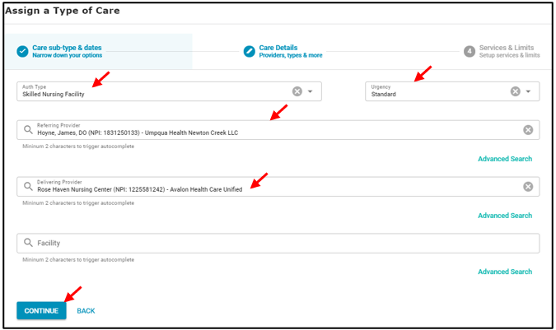
- Enter the diagnosis code(s) and procedure code(s) and select the populated option.  - Codes with a * are invalid and a valid code must be requested.  - Then enter the date range from the calendar icon. Enter the max units.  - UHA counts units as “visits” or dates of service.  - Max dollars should only be completed if requesting a rate/amount higher than contracted, DMAP or if no rate is established (SFA).  - Then select “ADD.”  - Select “CONTINUE” in the bottom left corner. | 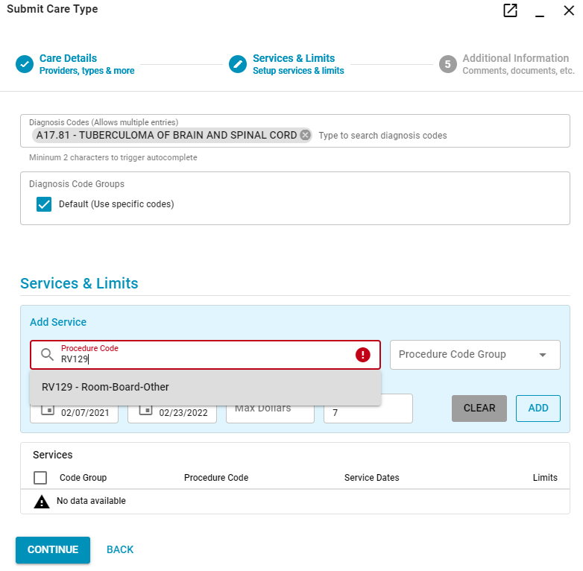
- Attach supporting documentation by selecting the “+” sign in the Attach Documents header.  - Add additional information in the “Comments” sections. If the referring/delivering provide did not populate, enter the provider’s name and NPI number here. If making a change or extending the stay (concurrent review) list the reference number of the previous auth and the change needed.  - Select continue in the bottom left corner. | 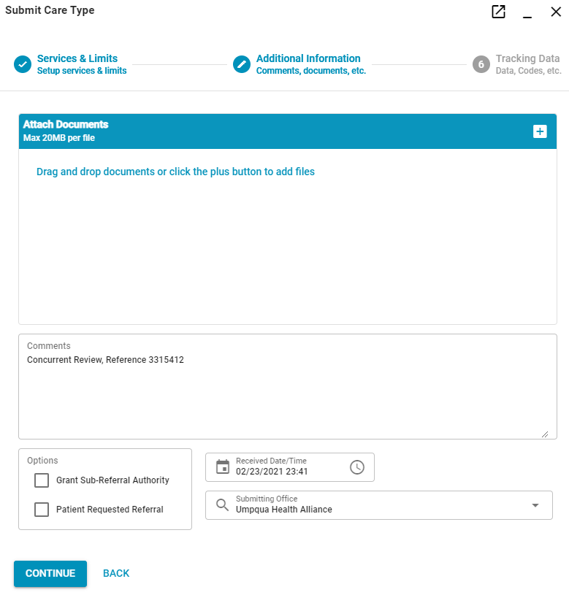
- In the next window, review your submission for accuracy. If no changes are needed, select “FINISH.”  - If changes or notes are needed, or you missed a step that you need to correct, you can select “REVIEW REFERRAL/AUTH.” | 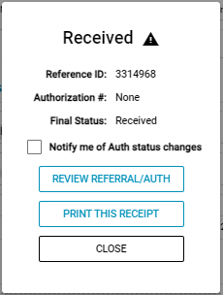

CORRECTIONS (CHANGES WHILE THE PA IS STILL PENDING DETERMINATION)
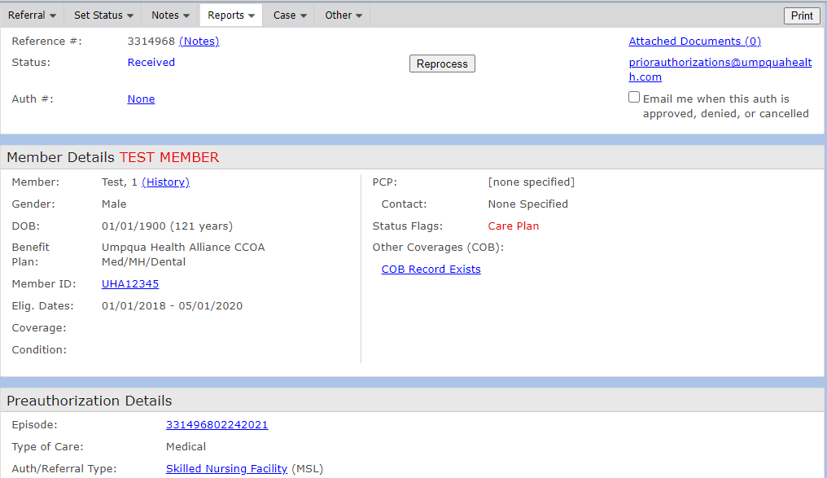
If the status of the PA is blue, you can edit the PA and send a CIM email to PriorAuthorizations@umpquahealth.com, noting the change made. Example: A wrong diagnosis code was entered, or incomplete documentation was attached.
If the status of the PA is approved or green, the determination has been complete, and an extension is required. Select “Extend Authorization” in the top right corner of the PA.
If the status of the PA is denied or denied partial or red, the determination has been complete, and a new PA request is required for changes.

PROCEDURE CODE GROUPS
UHA has combined certain procedure codes into code groups. This means you only need to enter one of these codes and the total quantity of visits instead of entering each code and quantity individually.
For example, we have combined Chiropractic codes 98940, 98941, 97110, 97140, 97124 into a code group. If you are requesting 98940 x 4, 98941 x 4, 97110 x 4, 97140 x 4, 97124 x 4 you will enter 98940 and select the Chiropractic Code group radio button on the right. Enter the max quantity of 4. You will have then requested all codes within the group, for 4 visits each.
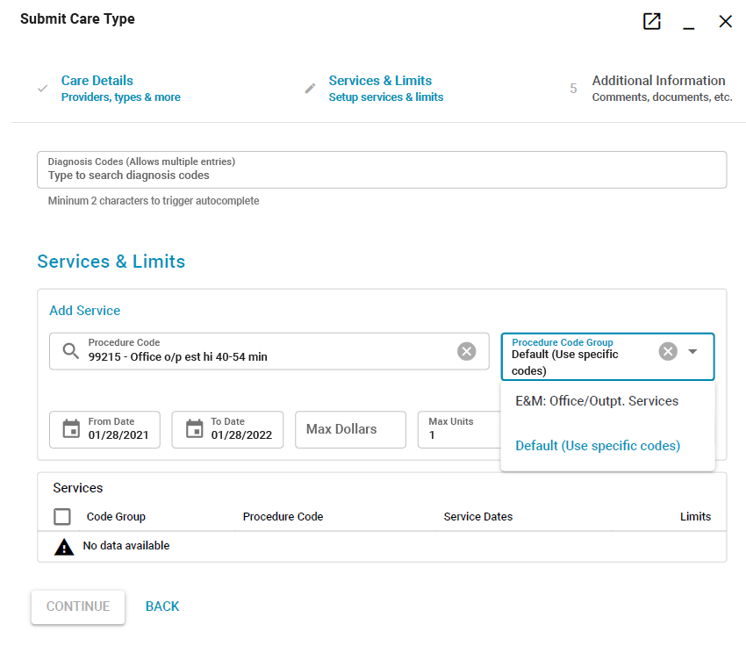
When submitting a prior authorization request, enter the diagnosis code, procedure code, date range and max units.
To select or view the availability of a code group, enter the procedure code, and select it from the autocompleted hyperlink. Then select the drop-down menu labeled “Procedure Code Group.”
If the only option is “Default (Use specific codes)” then there is not a code group available. If there is a code group available, it will appear in this list above the default option. Then select ADD.
You can also view the code group codes when reviewing your submission by selecting the “i” under the Code Group section of the service line.
To verify how codes within each code group are used, please refer to the Code Groups Instructional on our website at www.umpquahealth.com/priorauthorizations.

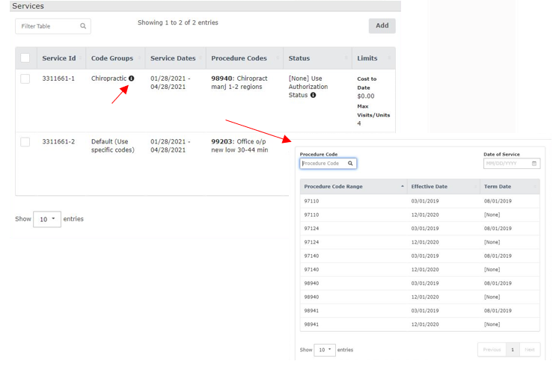

.

AMENDMENTS AND EXTENSIONS (FINAL STATUS)
An amend is anything that needs to be added or changed after a prior authorization has been finalized approved/denied/dismissed/withdrawn).
Internally, we use “amend” for an edit and “extension” for an inpatient request where we are extending the end date to cover the full stay. This is the terminology to be used in the comment field. URS will always reference the previous PA in sequence (not the original PA reference number). Every PA that has been extended, the last PA in sequence will override all previous extensions or associated PA’s (links).

Supporting documentation is required to add codes. Date/provider changes do not need supporting documentation attached, but is preferred (these are still valid requests, but will follow the “no documentation provided” workflow.

For providers with CIM access:
- A new request, submitted by the requesting provider, in the form of an extension. If URS identifies that it is an amend, a phone call/email to the provider to clarify and documentation supporting the amend (MMC note of phone call) is required.
- If a provide sends an email to UHA requesting an amend, URS are to reply with the email template indicating that they must resubmit as an extension and how. If the provider is unable to extend, have them submit the request as a new request indicate the change in the comment field, URS will link the requests together.
- Extensions for additional days requests (concurrent review) will have overlapping dates from the previous review. See specific auth type directions below.
For providers without CIM access:
- A new PA request form faxed to UHA detailing the change.

What can be amended? | What cannot be amended?
- Quantities  - Dates  - Referring/delivering providers  - CPT/Dx codes | - Start dates for retro office visit requests​.  - Quantities for DME rentals​  - Dates on DME rentals if request is for more months than approved​.  - Adding additional quantities on office visits​  - Extend the date on authorizations that have been expired over 30 days​.  - Extend the date or amend to add codes for a procedure not completed yet if the member has termed​.  - Remove or change CPT codes or providers if a claim has been filed.​

NOTIFICATION OF DETERMINATION
Once in a final status (Approved, Denied, Denied Partial, Withdrawn, Dismissed) the notification letter will be attached to the “Attached Documents” link in the top right corner. An email will be sent to the requesting provider informing them of the outcome. If the request was submitted via fax, the provider will be faxed the determination letter.

DENIED REQUESTS
Any decisions to deny, reduce, or authorize a service in an amount, duration, or scope less than what was requested are made by a medical or pharmacy director. UHA does not incentivize providers, employees, or other utilization reviewers to inappropriately deny, limit, or discontinue medically appropriate services to any member. These adverse benefit determinations will not be arbitrarily made solely because of diagnosis, type of illness, or condition of the member, subject to the Prioritized List of Health Services.

Before denying any member treatment for a condition that is below the funding line on the Prioritized List of Health Services for any member, including without limitation, disabilities, or co-morbid conditions, UHA shall determine whether the member has a funded condition/treatment pair that would entitle the Member to treatment under OAR 410-141-3820.

UHA will not apply more stringent utilization or prior authorization standards to out-of-network services, than standards that are applied to medical/surgical benefits. UHA may deny authorization requests for the following reasons. In each case, the member will receive a written denial notice that informs them of the reason for the denial and their appeal rights:
  - The denial or limited authorization of a requested service, including determinations based on the type or level of service, requirements for medical necessity, appropriateness, setting, or effectiveness of a covered benefit.
  - The reduction, suspension, or termination of a previously authorized service.
  - The denial, in whole or in part, of payment for a service. This excludes any claim that is not a clean claim. Clean claim means one that can be processed without obtaining additional information from the provider of the service or from a third party. It includes a claim with errors originating in a State's claims system. It does not include a claim from a provider who is under investigation for fraud or abuse, or a claim under review for medical necessity.
  - The failure to provide services in a timely manner, as defined by the State.
  - The failure of UHA to act within the timeframes provided in § 438.408(b)(1) and (2) regarding the standard resolution of grievances and appeals.
  - For a resident of a rural area with only one managed care organization, the denial of a member’s request to exercise his or her right, under § 438.52(b)(2)(ii), to obtain services outside the network.
  - The denial of a member’s request to dispute a financial liability, including cost sharing, copayments, premiums, deductibles, coinsurance, and other member financial liabilities.

UHA may place appropriate limits on services for the following:
- On the basis of criteria applied under the State plan (such as medical necessity).
- For the purpose of utilization control, provided that:
    - The services furnished can reasonably achieve their purpose.
    - The services supporting individuals with ongoing or chronic conditions or who require long-term services and supports are authorized in a manner that reflects the member’s ongoing need for such services and supports.
    - Family planning services are provided in a manner that enables the member to choose the method of family planning.

If UHA is going to reduce, suspend, or terminate a previously authorized Medicaid-covered service, advance notice will be given (notice of adverse benefit determination) at least ten (10) days before the proposed effective date except when:
- The CCO gives notice on or before the date of action if:
  - The agency has factual information confirming the death of a member.
  - The agency receives a clear written statement signed by the member that he/she no longer wishes services or gives information that requires termination or reduction of services and indicates that he/she understands that this must be the result of supplying that information.
  - The member has been admitted to an institution where he/she is ineligible under the plan for further services.
  - The member’s whereabouts are unknown, and the post office returns agency mail directed to him/her indicating no forwarding address.
  - The agency establishes the fact that the member has been accepted for Medicaid services by another local jurisdiction, State, territory, or commonwealth.
  - A change in the level of medical care is prescribed by the member’s physician.
  - The notice involves an adverse determination made with regard to the preadmission screening requirements.
- If probable member fraud has been verified, the CCO gives notice five (5) calendar days before the date of action.

NOTICE OF ADVERSE BENEFIT DETERMINATIONS (DENIAL NOTICE)
A written notice will be sent to the member for all services that have been denied, reduced, terminated, limited, or authorize a service in an amount, duration, or scope less than what was requested. The notice will meet the language and format requirements of 42 CFR §438.10(c). This notice will be attached to the request as noted above, and the letter will be mailed to the member along with information on how to appeal the decision. This will be sent within the time frames as specified above and in CFR 42 CFR §438.210(c). If a decision is not reached within the required time frame, the letter will be sent on the date the time frame expires.

The notice of adverse benefit determination explains the following:
- Language access statement clarifying that oral interpretation is available for all languages and how to access it and a non-discrimination statement stating that UHA may not treat members unfairly due to their age, color, disability, gender identity, marital status, national origin, race, religion, sex, or sexual orientation.
- UHA’s contact information including name, address, and telephone number.
- Date of the notice.
- Name of the member’s primary care provider (PCP), primary care dentist (PCD), or behavioral health professional if the member has an assigned practitioner. If the member has not yet been assigned a practitioner due to recent enrollment, the NOABD should state that PCP, PCD, or behavioral health professional assignment has not occurred.
- Member’s name, date of birth, address, and OHP ID number.
- Description and explanation of the service(s) requested and the adverse benefit determination UHA intends to make, including whether the UHA is denying, terminating, suspending, or reducing a service.
- Date the service was requested by the provider or member.
- Name of the provider who requested the service.
- Effective date of the adverse benefit determination if different from the date of the NOABD.
- Diagnosis and procedure codes submitted with the authorization request, including a description in plain language if UHA is denying a requested service because of line placement on the prioritized list or the diagnosis and procedure code do not pair on the prioritized list.
- Other conditions UHA considered including but not limited to: co-morbidity factors if the service was below the funding line on the prioritized list; statement of intent governing the use and application of the prioritized list to requests for health care services including the placement of the condition/diagnosis code on the prioritized list; and other coverage for services addressed in the State 1115 Waiver;
- Clear and thorough explanation of the specific reasons for the adverse benefit determination.
- A reference to the specific sections of the statutes and administrative rules to the highest level of specificity for each reason and specific circumstances identified in the NOABD.
- The member’s right or, if the member provides written consent as required under OAR 410-141-3890(1), the provider’s right to file a written or oral appeal of CCO’s adverse benefit determination with UHA, including information on exhausting UHA’s one level of appeal, and the procedures to exercise that right.
    - The appeal information to members includes following information:
      - The sixty (60) days’ time limit for filing an Appeal.
      - The toll-free numbers that the Member can use to file an Appeal by phone.
      - The availability of assistance in the filing process.
      - The process to request a Contested Case Hearing after an Appeal.
      - The rules that govern representation at the Contested Case Hearing; and
      - The right to have an attorney or Member Representative present at the Contested Case Hearing and the availability of free legal help through Legal Aid Services and Oregon Law Center, including the telephone number of the Public Benefits Hotline, 1-800-520-5292, TTY 711.
- The member’s or the provider’s right to request a contested case hearing with OHA only after UHA’s notice of appeal resolution or where CCO failed to meet appeal timelines in OAR 410-141-3890 and 410-141-3895, and the procedures to exercise that right.
- The circumstances under which an expedited appeal resolution and an expedited contested case hearing are available and how to request.
- The member’s right to have benefits continue pending resolution of the appeal, how to request that benefits be continued, and the circumstances under which the member may be required to pay the costs of the services.
- The member’s right to receive from UHA, upon request and free of charge, reasonable access to and copies of all documents, records, and other information relevant to the member’s adverse benefit determination; and
- Copies of the appropriate forms as listed in OAR 410-141-3885.
    - Language Access Taglines
    - Non-discrimination Notice
    - Request to review a health care decision (OHP 3302)

PEER-TO-PEER CONSULTATION
UHA allows for consultation with a requesting Provider for medical services when necessary for both initial and continuing PA requests. This can be done by calling our main line at 541-229-4842, option 1 or by emailing priorauthorizations@umpquahealth.com. Using the same contact method above, providers can schedule a peer-to-peer. Peer-to-peer can occur at the same time a member is in the process of appealing a denial.

INCOMPLETE (IN-VALID): MISSING INFORMATION
Requests will be determined valid within two days of receipt. For the PA to be a valid submission, the following must be included:
  - Current CPT/HCPC code(s).
  - Current ICD-10 Diagnosis code(s).
  - Referring Provider; and
  - Delivering Provider (facility for procedures, rendering provider for referrals).

A Utilization Review Specialist (URS) will review the request. If the request is invalid, a URS will attempt to obtain the missing/incomplete information in three (3) attempts, in two (2) different modes (fax/email/phone). The request will be loaded into CIM for tracking and documentation and placed in the Additional Information queue. If needed, use dump code “ExReq” for missing diagnosis (Dx) or procedure codes.

These requests will be dismissed and will require a new submission for review.

INCOMPLETE (VALID): SUPPORTING DOCUMENTATION
A Utilization Review Specialist (URS) will review the request. If the request is valid, but was not requested with supporting documentation, chart notes, etc. a URS will attempt to obtain the missing/incomplete documentation in three attempts, in two different modes (fax/email/phone). The request will be loaded into CIM for tracking and documentation and placed in the Additional Information queue. If the information is not obtained after three attempts within 10 days, URS will then route the PA to the appropriate UM queue. A Utilization Review Coordinator (URC) will then make a determination without the requested notes and likely lead to a denial of services until a new submission can be sent.

If the documentation is received, a determination will be made within three (3) days. Additionally, clinical and support staff may consult with the requesting provider, when appropriate.

SPECIAL FINANCIAL ARRANGEMENTS (SFA) AND SINGLE CASE AGREEMENTS (SCA)
All provider requests for Single Case Agreements must be made at the time of the prior authorization request. This can be indicated on the PA Form with the listed rate (OON) or in the comment field of the request made in CIM. Additionally, if a service or item is not on the DMAP fee schedule, or the provider is requesting a rate higher than the DMAP, URS ensure this price is listed in the max cost field and “SFA” or “SCA” as applicable are indicated in the Comments field.
    - SFA: See DME, Prosthetic/Orthotic, Audiology, Vision, etc.
    - SCA: OON IP stays (i.e., SNF, Hospitalization, BH Res/IP, etc.)

SCA’s will not be allowed for in-network providers. If a higher rate is indicating an amount in the max cost field, URS will determine if the request has a DMAP fee or contracted rate. If so, they will remove this amount and send the provider a notice stating their contracted rate. If there is not an established rate, the request will be processed as an SFA request.

CIM STATUS
Status name (queue) | Status meaning | Status name (queue) | Status meaning
Received | Pending, Submission successful, not yet reviewed | Dismissed | Final, request was a duplicate, error, or invalid. See cancelation notice in the attached documents link
Additional info requested | Pending, UHA needs more information, check the Notes and/or communications for needed updates | Withdrawn | Final, submitter/office requested the PA to be canceled. See cancelation notice in the attached documents link.
Support Specialist 1-16 | Pending, request is being validated. Not yet to review. | Approved | Final approved, see approval notice in the attached documents link
UM 1-16 | Pending, request is being reviewed for coverage and medical appropriateness | Approved – As Amended | Final approved, request is the final PA in an amendment. See approval notice in the attached documents link
Provider Info Sent | Pending, request had notes attached. Will be sent to review. | Approved – Concurrent Review | Final approved, request will need to be updated by end date of PA with concurrent review request for additional days or a discharge summary to close. Used for inpatient and residential PA requests only. See approval notice in the attached documents link
Post Approved | Pending, a determination has been made and as waiting for a final validation review and notification to be sent to provider. | Approved – Concurrent Review Discharge | Final approved, discharge summary has been received. See approval notice in the attached documents link
Post Denied | Pending, a determination has been made and as waiting for a final validation review and notification to be sent to provider. | Denied – No Pre-Authorization  Denied – Non-Panel Provider  Denied - Not a Covered Service  Denied – Not Medically Appropriate | Final denied, request will not be authorized in whole. See denial notice in the attached documents link
 |  | Denied Partial – No Pre-Authorization  Denied Partial – Non-Panel Provider  Denied Partial - Not a Covered Service  Denied Partial – Not Medically Appropriate | Final denied, request will not be authorized in part. See the service request lines for each code determination. See denial notice in the attached documents link

QUALITY AUDITING AND MONITORING
Daily: UM monitors all requests through a twice daily referral report. This lists all requests received and within CIM and their status.
Concurrent Review: UM monitors Concurrent Review Status for approved inpatient stays. URS will reach out to submitters to obtain concurrent review documentation for PA’s due in one day, one day past due, and one week, three weeks past due. The final status of a PA will not be changed to “Approved – Concurrent Review Discharge until the necessary discharge paperwork is received. This is to ensure that the dates of service are correct and will not interfere with billing.
Auth without Mailings Report: UM monitors all requests through a twice daily auth without mailing report. The report will identify prior authorizations that have been placed in a final determination, but a notification was not generated for the provider and member.

Quality Audits: UM monitors quality of processing of requests and procedures through quality audits. These are preformed weekly and used for process improvements, oversight, trainings, and coaching opportunities. Additionally, medical review audits are conducted to ensure correct use of determination tools (Prioritized List, Guideline Notes, Clinical Practice Guidelines, InterQual, OARs, etc.) and properly sited in denial quote. Additionally, UM monitors annual set Key Performance Indicators (KPI) for previous month for compliance. This data includes turn-around-times for expedited, standard, SNF, and SUD authorization requests. In addition to the quantity of expedited and standard appeal and grievance requests and notification requirements. Failure to meet threshold requirements will result in corrective action plans.

Inter-rater Reliability (IRR) Testing: To ensure consistent application of review criteria for authorization decisions, UHA conducts IRR assessments twice per year either through the use of InterQual© IRR assessment tool or manual review of sample cases that are provide by the department manager. Each clinical staff member is responsible for reviewing PA requests will receive either a link to the InterQual© IRR assessment tool or an email containing the list of sample cases.
- Clinical staff will complete the IRR assessment within the given timeframe. A passing score of 80% or higher is considered proficient.

PRIOR AUTHORIZATION STANDARD REQUESTED DURATIONS
Auth Type | PA Timeframe
ACUPUNCTURE | 8 Weeks
BEHAVIORAL HEALTH - ABA - ADULT | 6 Months
BEHAVIORAL HEALTH - ABA - CHILD | 6 Months
BEHAVIORAL HEALTH - ACT | 90 Days
BEHAVIORAL HEALTH - IIBHT | 60 Days (Initial); 30 Days (Ongoing)
BEHAVIORAL HEALTH - IP ADULT | 7 Days
BEHAVIORAL HEALTH - IP CHILD | 7 Days
BEHAVIORAL HEALTH - OP ADULT | 3 Months
BEHAVIORAL HEALTH – OP CHILD | 3 Months  (6 months allowed for initial assessment for Psychological Evaluations)
BEHAVIORAL HEALTH - PRTS | 30 Days (Initial); 14 Days (Ongoing)
BEHAVIORAL HEALTH - PSYCHOLOGICAL EVAL ADULT | 12 Months
BEHAVIORAL HEALTH - PSYCHOLOGICAL EVAL CHILD | 12 Months
BEHAVIORAL HEALTH - RES ADULT | 30 Days (Initial); 14 Days (Ongoing or Continuation of Care)
BEHAVIORAL HEALTH - RES CHILD | 30 Days (Initial); 14 Days (Ongoing or Continuation of Care)
BEHAVIORAL HEALTH - SUD - CHILD | *Consistent With Adult Auth Types
BEHAVIORAL HEALTH - SUD - DETOX | 4 Days
BEHAVIORAL HEALTH - SUD - DETOX NIDA | 4 Days
BEHAVIORAL HEALTH - SUD - OP | 3 Months
BEHAVIORAL HEALTH - SUD - RESIDENTIAL | 30 Days (Initial); 7 Days (Ongoing)
CHIROPRACTIC | 8 Weeks
DERMATOLOGY | 6 Months – 1 Year (Initial/Referral/ Follow-Up); 3 Months (Treatment)
DIAGNOSTIC SERVICES | 6 Months – 1 Year
DURABLE MEDICAL SUPPLIES | **Depends on the request
HOME HEALTH | 30 - 60 Days
HOSPICE | 2 Weeks – 1 Year
HOSPITALIZATION/ADMISSIONS | 7 Days
IMAGING | 6 Months – 1 Year
INPATIENT SURGERY SERVICES | 6 Months – 1 Year
MFM | 1 Year
PHYSICAL/OCCUPATIONAL/SPEECH THERAPY SERVICES | 8 Weeks
RESIDENTIAL REHABILITATION/LTAC | 14 -30 Days (Initial); 7-14 Days (Ongoing) **Treatment Plan Dependent
SKILLED NURSING FACILITY | 7 Days (Initial); 7 Days (Subsequent Ongoing); 6 Days (Final Ongoing)
SPECIALIST REFERRALS: | 6 Months – 1 Year
TRANSPLANTS | 1 Year

CARE COORDINATION
Through the UM and hospital notification process, UM refers members to UHA’s Intensive Care Coordinators (ICC) within Arcadia (Care Coordination Platform). The ICC will work with the member and the care team through care plans, Interdisciplinary teams, and other care coordination activities. Additionally, UM will refer members to, if necessary, identified in the medical notes provided to support the PA request.

UTILIZATION MANAGEMENT SYSTEM & RELATED POLICES
CE01 – Grievances, Appeals, and Hearings
CE04 - Outpatient Behavioral Health Services Prior Authorization
CE05 - Medical and Pharmacy Review
CE06 - Children and Youth Behavioral Health Services
CE07 - Other Benefits Not Covered by UHA
CE08 - Behavioral Health Provider Requirements
CE10 - Second Opinion for Health Care Services
CE11 - Out of Network Services
CE12 - Prior Authorization
CE13 - Emergency Care and Post Stabilization
CE15 - Specialty Health Care Services
CE17- Single-Case Agreements
CE19 - Substance Use Disorder Services
CE21 - Adverse Benefit Determinations
CE22 - Payment & Authorization for Hospital Admission
CE23 - Payment and Authorization of Inpatient Psychiatric Hospital
CE24 - Mental Health Parity
CE28 - Transition of Care
QI02 - Over and Under Utilization
QI06 - Clinical Practice Guidelines
MS2 – Nondiscrimination of Members
MS4 – Written Notices to Members
PN6 – Provider Orientation and Training

