FAQ
How to use Umpqua Health Alliances Automated Claim Status Phone System

- What information can the new automated system provide? Claim status will always be provided. Depending on the current status billed charges, net payment amount, check number, and check date will also be provided.
- When are providers required to use the automated phone system? When checking the status of a claim where the earliest date of service after 1/1/2019.
- What information does a provider need to have to look up information?
  - The earliest date of service on the claim in a YYYYMMDD format (ex 01/01/2022 would be 20220101),
  - The first three numbers in the Member’s ID (ex ABC1234D would be 123)
  - The last four digits in the claim number (ex 01012022E12345 would be 2345).
- What are the hours of operation for the automated claim Status Phone System? This option is available seven days a week and on Holidays. The only time it is closes is for one hour a day for the data to refresh (Currently set for12:00 am – 1:00 am Pacific Time).
- How do I reach a live person? See chart below.
- What are some tips to better use the automated system? Press “1” to confirm the information you entered is correct, there is no need to wait for the prompt to ask for confirmation. Do not press the pound key, the system will automatically end the call.

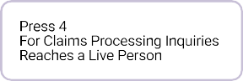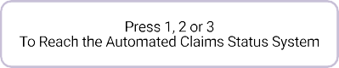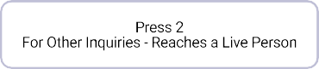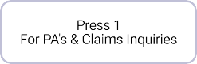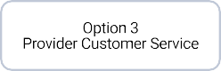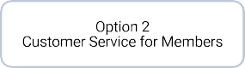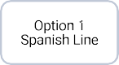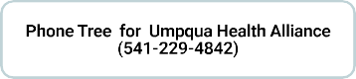

1 of 1 6/1/2022, 3:36 PM

