**UHA Provider Interactive Voice Response (IVR) User Guide**

**Helpful Tips**

To find a claim using the IVR system, have all of the information available and organized before you call including:

* Member ID
* Date of Service
* Patient Account/Invoice Number
* Rendering provider NPI for professional claims
* Billing provider NPI for institutional claims

Speak naturally and clearly in a quiet environment.

Use mute when you are not speaking.

Avoid the use of cellular phones or speaker phones.

Use touch‐tone if an element is not recognized by your voice.

**The Nato-Phonetic Alphabet**

To assist you when speaking terms that are alpha-numeric, we have implemented the phonetic alphabet. When speaking an alpha character, please use the Military word (Nato-phonetic alphabet) below. If the patient account number is 123B45, you will speak the following in the IVR: one, two, three, Bravo, four, five. Do not say things like “A as in Alpha ,” if there is an A, just say “Alpha.”

Do not use other words. Only use the words provided.

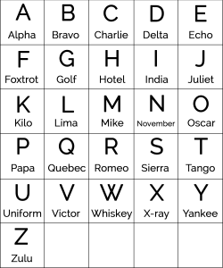

**Using Touch-Tone**

The IVR is programmed to allow for the entry of all data using touch‐tone in the event the user is unable to successfully speak to the IVR. These instructions detail how to use touch‐tone to enter various types of information requested by the IVR.

Note: You can switch between voice and touch‐tone throughout the call; however, you cannot combine speech and touch‐tone when providing a single element (e.g., voice for the numbers in a NPI and then touchtone for DOS.

**Claims Phone Menu Options**

